**A**

**PROJECT REPORT**

**ON**

**“MindFulMe”**

***Submitted by***

**Pratham Vaghela(20IT416)**

**Ayush Patel(20IT418)**

**Manan Goradia(20IT484)**

**For Partial Fulfillment of the Requirements for Bachelor of Technology in**

**Information Technology**

**Guided by**

**Prof. Dharmesh Patel**

**May, 2024**



**Information Technology Department**

**Birla Vishvakarma Mahavidyalaya Engineering College**

**(An Autonomous Institution)**

**Vallabh Vidyanagar – 388120**

**Gujarat, INDIA**

* 1. **Project Definition:**

The project aims to develop a comprehensive mental health application that provides users with a variety of activities and resources to support their mental well-being. The app will include features such as Morning Meditation, Journaling, Night Music, Sherlock Holmes (a mental stimulation activity), Mental Marathon and more. Additionally, the app will offer brain games, weekly and monthly analysis reports, gamification elements, and feedback mechanisms to enhance user engagement and track progress.

* 1. **Project Objective:**

The primary objective of the project is to create a user-friendly and effective mental health app that promotes well-being through a diverse range of activities and resources. The app aims to provide users with tools to manage stress, improve mood, enhance cognitive function, and cultivate positive mental habits. By offering a combination of mindfulness practices, cognitive exercises, relaxation techniques, and entertainment options, the app seeks to support users in their journey towards better mental health and overall well-being.

* 1. **Project Scope:**

The MindFulMe app is designed to cater to a wide range of users, including individuals who may be experiencing stress, anxiety, depression, or other mental health challenges. The scope of the app includes features such as mental health assessment questions, daily activities and challenges, user profile management, and general settings for customization and privacy options. While the app aims to provide valuable support and resources for mental well-being, it acknowledges its limitations and the importance of seeking professional help for severe mental health conditions.

* 1. **Project Modules:**
     1. **Activities:**
* The Activities module within the mental health application serves as a comprehensive toolkit designed to promote holistic well-being and aid users in cultivating positive habits for mental wellness. Tailored to suit individual preferences and needs, this module offers a diverse range of activities aimed at fostering relaxation, mindfulness, creativity, and personal growth.

1. **Morning Meditation:**

The Morning Meditation is designed to provide users with a serene start to their day by offering guided meditation sessions within the application. This feature aims to promote mental well-being, cultivate mindfulness, and enhance users' overall experience.

1. **Night Music:**

The Night Music enhances users' relaxation and promotes better sleep by providing a curated selection of calming music tracks within the application. Designed to create a tranquil atmosphere conducive to rest and rejuvenation, this feature offers an immersive audio experience tailored to help users unwind and prepare for a restful night's sleep.

1. **Gratitude:**

* The Gratitude is designed to foster a positive mindset and cultivate an attitude of appreciation and thankfulness within the application. By providing users with a platform to express gratitude and reflect on the blessings in their lives, this feature aims to promote emotional well-being, resilience, and a deeper sense of fulfillment.

1. **Mental Marathon:**

* The "Mental Marathon" module is an engaging and dynamic quiz experience designed to challenge and stimulate the user's cognitive abilities. By featuring questions across various domains such as aptitude, verbal reasoning, coding, and decoding, this module provides a comprehensive mental workout.

1. **Sherlock Holmes:**

* The "Sherlock Holmes" module introduces a captivating and interactive image-based question experience, where users can channel their inner detective. Inspired by the renowned detective Sherlock Holmes, this module challenges users to observe, analyze, and deduce based on a given image.

1. **Daily Thoughts:**

* The Daily Thoughts offers users a source of inspiration, reflection, and motivation within the application. Through curated quotes, affirmations, and reflections, this feature aims to uplift users' spirits, encourage positive thinking, and foster personal growth and self-discovery on a daily basis.

1. **Study Music:**

* The Study Music provides users with a curated selection of instrumental music tracks designed to enhance focus, concentration, and productivity during study or work sessions within the application. By offering a conducive auditory environment, this feature aims to optimize users' learning and cognitive performance while fostering a sense of tranquility and flow.

1. **Kindness Challenge:**

* The Kindness Challenge encourages users to spread positivity and make a positive impact on the world through acts of kindness within the application. By offering a series of challenges and prompts, this feature aims to inspire users to practice compassion, empathy, and generosity in their daily lives, fostering a culture of kindness and goodwill.

1. **Affirmation:**

* The Affirmation offers users a collection of positive affirmations and empowering statements within the application. Designed to boost confidence, self-esteem, and well-being, this feature provides users with personalized affirmations tailored to various aspects of their lives, including relationships, career, health, and personal development.

1. **Music:**

* The Music enriches users' experience within the application by providing access to a diverse library of music tracks spanning various genres, moods, and styles. Whether users seek relaxation, motivation, or entertainment, this feature offers a comprehensive selection of music to cater to their preferences and enhance their overall user experience.

1. **Tratak:**

* The Tratak module offers users a guided meditation experience focused on the ancient yogic practice of Tratak, or steady gazing. Rooted in mindfulness and concentration, Tratak meditation involves gazing at a specific object or point to cultivate focus, clarity, and inner stillness. This submodule provides users with a structured approach to Tratak meditation, facilitating relaxation, stress reduction, and mental clarity.

1. **Power Nap:**

* The Power Nap is designed to help users optimize their rest and rejuvenation through brief and effective nap sessions within the application. Drawing on scientific research on the benefits of power napping, this feature offers users guided nap sessions aimed at boosting energy, improving cognitive function, and enhancing overall well-being in a short period.

1. **Journal:**

* The Journal provides users with a personal space for reflection, expression, and self-discovery within the application. Offering a digital platform for journaling, this feature allows users to record their thoughts, feelings, and experiences, facilitating introspection, goal-setting, and personal growth in a convenient and accessible format.
  + 1. **Report:**
* The Report Module is a feature designed to provide users with comprehensive insights and analytics on their usage, progress, and performance within the application. By aggregating data from various modules and functionalities, the Report Module aims to empower users to track their achievements, identify areas for improvement, and make informed decisions to optimize their personal development journey.
* The Report module within the mental health application serves as a vital component for users to gain insights into their engagement and progress across various activities offered by the platform. Through intuitive visualization tools such as bar charts, pie charts, and more, users can effectively monitor their participation and performance in specific sub-modules over both weekly and monthly periods.

1. **Morning Meditation report:**

* The Report module offers graphical insights into users' morning meditation habits. Visual charts track session frequency and duration, aiding users in optimizing their meditation routine for enhanced mental clarity and well-being.

1. **Mental Marathon report:**

* Users gain visual feedback on their engagement with mental challenges and cognitive exercises. Performance metrics highlight completion rates and accuracy, empowering users to refine their cognitive skills and problem-solving abilities.

1. **Sherlock Holmes report:**

* Through graphical representations, users can assess their performance in detective-themed activities. Metrics such as success rates and time spent on puzzles provide actionable insights for honing analytical skills and fostering a sharp investigative mindset.

1. **Night Music report:**

* The Report module offers visual summaries of users' listening habits and music preferences. Metrics like listening duration and mood correlations help users curate personalized playlists for relaxation and improved sleep quality.
  + 1. **Games:**
* The Games module offers users a collection of engaging games designed to enhance cognitive skills, improve focus, boost memory, and promote overall well-being. Users earn points by progressing through game levels, fostering motivation and excitement for continuous play. These points unlock new levels and challenges, encouraging users to embark on a rewarding journey of skill development and mental stimulation poll.
* Within the Games module, users access a diverse array of interactive challenges tailored to bolster cognitive abilities, heighten focus, and enhance memory retention. Progressing through game levels not only earns users points but also fuels their enthusiasm to conquer new challenges. These points serve as keys to unlock exciting new levels and experiences, fostering a sense of achievement and incentivizing daily engagement. Through immersive gameplay experiences, users embark on a journey of skill refinement and positive mental stimulation, unlocking their full potential along the way.
  + 1. **Gamification:**
* In the Gamification module, users earn points upon completing various activities, incentivizing consistent engagement. Accumulated points unlock badges, serving as tangible rewards for accomplishments. These points also grant access to new features and additional content, fostering motivation and progression within the application's ecosystem. Through gamified elements, users are encouraged to actively participate, achieve milestones, and unlock a fulfilling journey of self-improvement and exploration.
* Within the Gamification module, user engagement is incentivized through a dynamic points system tied to activity completion. As users accomplish tasks, they earn points, which not only unlock badges as recognition but also serve as currency for accessing exclusive features and content. This gamified approach transforms routine activities into rewarding experiences, motivating users to strive for continuous improvement and exploration within the application. Through this immersive gamification framework, users are empowered to chart their progress, earn rewards, and embark on a fulfilling journey of personal growth and discovery.
  + 1. **Dash-Board (Admin panel):**
* Admin panel empowers administrators with comprehensive control over the application's functionalities and content. Admins possess the authority to manage various aspects, including user accounts, music playlists, and game offerings, with the ability to add, modify, or remove content as needed. Additionally, the admin panel provides insightful data visualization tools, enabling administrators to analyze user-related metrics and trends through graphical representations. Beyond content management, the dashboard facilitates routine administrative tasks and customization options, ensuring seamless operation and tailored user experiences. With its intuitive interface and robust features, the admin panel serves as a central hub for overseeing application operations and driving continuous improvement.
* The Dashboard module serves as the nerve center for administrators, offering an array of tools for streamlined management and optimization of the application. Administrators wield authority to curate the user experience by fine-tuning music selections, game offerings, and user access privileges. Furthermore, the dashboard provides detailed analytics and visualizations, empowering administrators to glean insights into user engagement patterns, demographic trends, and content popularity. Through the admin panel's intuitive interface and robust functionality, administrators can efficiently monitor performance metrics, address user feedback, and implement strategic enhancements to ensure the application remains dynamic and responsive to evolving user needs.
  1. **Project Basic requirements:**
* **Hardware Interface:**

1. Hardware Environment: Dual Core 5th Generation and Onwards.
2. System Configuration: Minimum RAM-8GB, Minimum SSD-128GB
3. Operating System: Windows 10 and onwards.

* **Software Interface:**

1. VS Code: **Visual Studio Code** (famously known as **VS Code**) is a free open-source text editor by Microsoft. VS Code is available for Windows, Linux, and macOS. Although the editor is relatively lightweight, it includes some powerful features that have made VS Code one of the most popular development environment tools in recent times.
2. Firebase: Google Firebase is a dynamic platform packed with essential tools for app development, including real-time database capabilities for seamless data synchronization, authentication services for secure user access, scalable cloud storage solutions, and robust analytics features for insightful user engagement tracking. With Firebase, developers can streamline their development process, improve app quality, and optimize user experiences, ultimately driving greater success and monetization opportunities for their applications.
3. Flutter: Flutter, Google's open-source UI toolkit, enables developers to build natively compiled applications for mobile, web, and desktop from a single codebase. Its reactive framework facilitates rapid development, expressive UI designs, and seamless performance across platforms. With hot reload functionality and a rich set of pre-built widgets, Flutter streamlines the development process, allowing for quick iteration and experimentation. Whether creating prototypes or production-ready apps, Flutter offers an efficient and innovative development experience.
4. Dart: Dart is a versatile programming language developed by Google, known for its simplicity, speed, and scalability. Designed for building robust web, mobile, and server applications, Dart offers features like strong typing, asynchronous programming, and a rich standard library. With its ahead-of-time compilation and just-in-time execution capabilities, Dart enables efficient development and high-performance execution across various platforms.
   1. **Diagrams:**

* **Use case Diagrams:**

Use case diagrams are a common way to communicate the major functions of a software system. A use case diagram at its simplest is a representation of a user's interaction with the system that shows the relationship between the user and the different use cases in which the user is involved. A use case diagram can identify the different types of users of a system and the different use cases and will often be accompanied by other types of diagrams as well.

Use cases are nothing but the system functionalities written in an organized manner. Now another thing which is relevant to the use cases are the actors. Actors can be defined as something that interacts with the system.

So, in brief, the purposes of use case diagrams can be as follows:

➢ Used to gather requirements of a system.

➢ Used to get an outside view of a system.

➢ Identify external and internal factors influencing the system. Show the interacting among the requirements are actors

**Symbols used in Use Case diagram:**

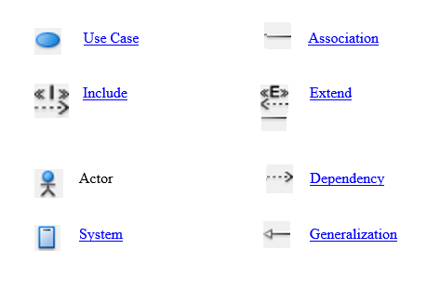

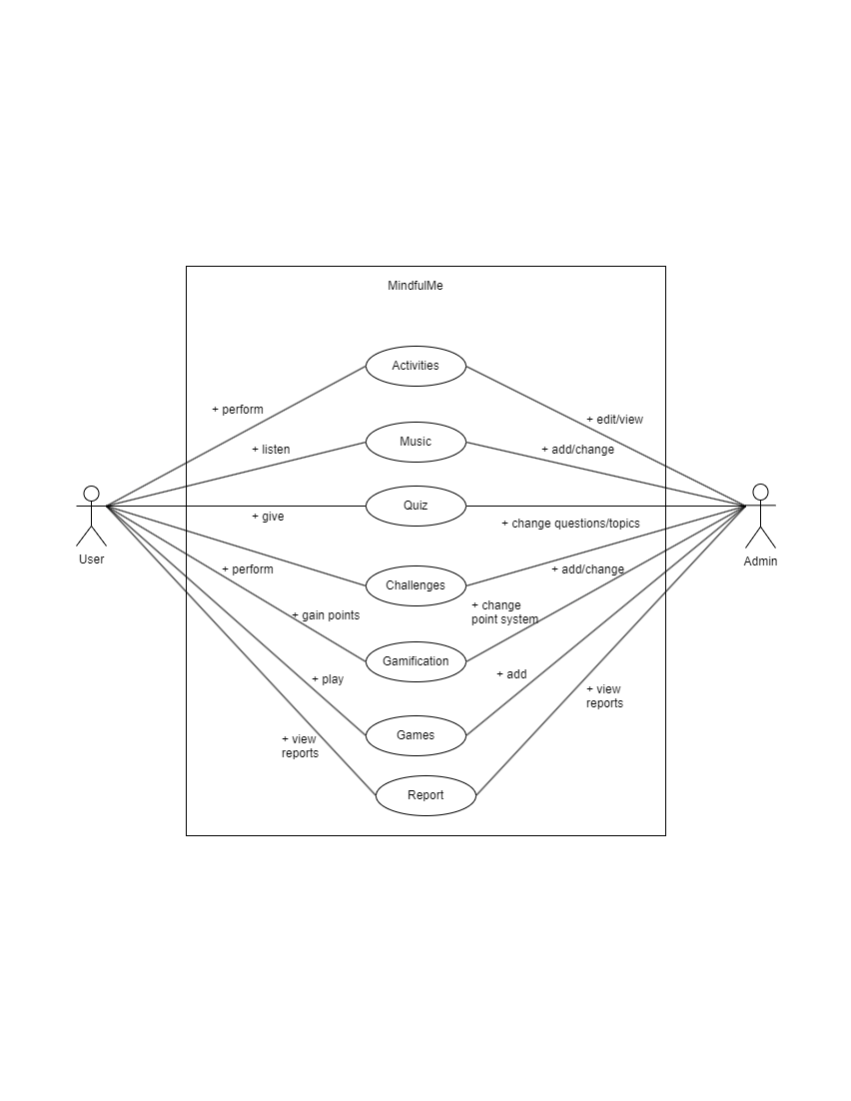

* **Class Diagram:**

The class diagram is the main building block of object-oriented modelling. It is used both for general conceptual modelling of the systematics of the application, and for detailed modelling translating the models into programming code. Class diagrams can also be used for data modelling. The classes in a class diagram represent both the main elements, interactions in the application, and the classes to be programmed.

In the diagram, classes are represented with boxes that contain three compartments **:**

• The top compartment contains the name of the class. It is printed in bold and centered, and the first letter is capitalized.

• The middle compartment contains the attributes of the class. They are left-aligned and the first letter is lowercase.

• The bottom compartment contains the operations the class can execute. They are also left-aligned and the first letter is lowercase.

In the design of a system, a number of classes are identified and grouped together in a class diagram that helps to determine the static relations between them. With detailed modelling, the classes of the conceptual design are often split into a number of subclasses.

**Symbols Used in Class Diagram:**

**Class:**

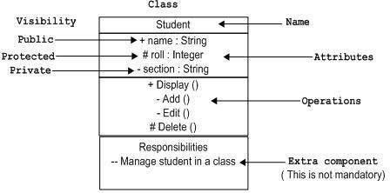

Association

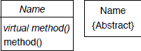Composition or Association

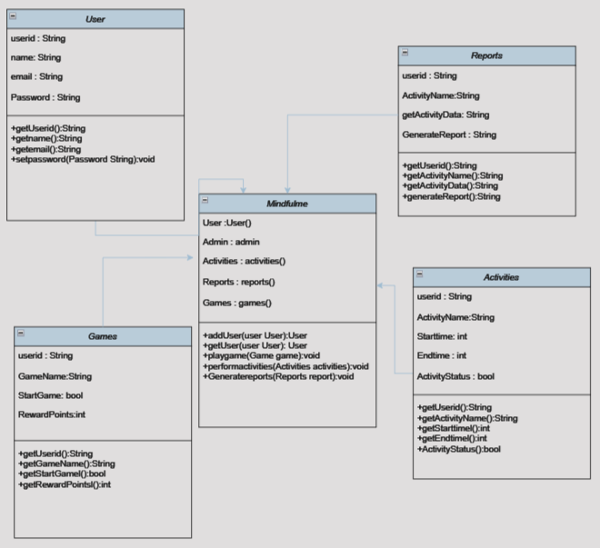

* **Entity Relationship Diagram:**

Entity-Relationship model is used to represent a logical design of a database to be created. In ER model, real world objects (or concepts) are abstracted as entities, and different possible associations among them are modelled as relationships. We represents the attributes, entities and relation using the ER diagram. Using this ER diagram, table structures are created, along with required constraints. Finally, these tables are normalized in order to remove redundancy and maintain data integrity. Thus, to have data stored efficiently, the ER diagram is to be drawn as much detailed and accurate as possible.

**Symbols Used in E-R Diagram:**

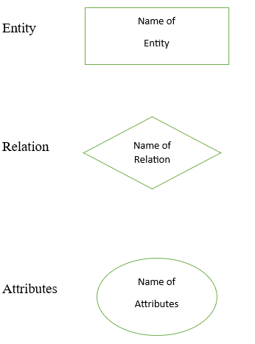

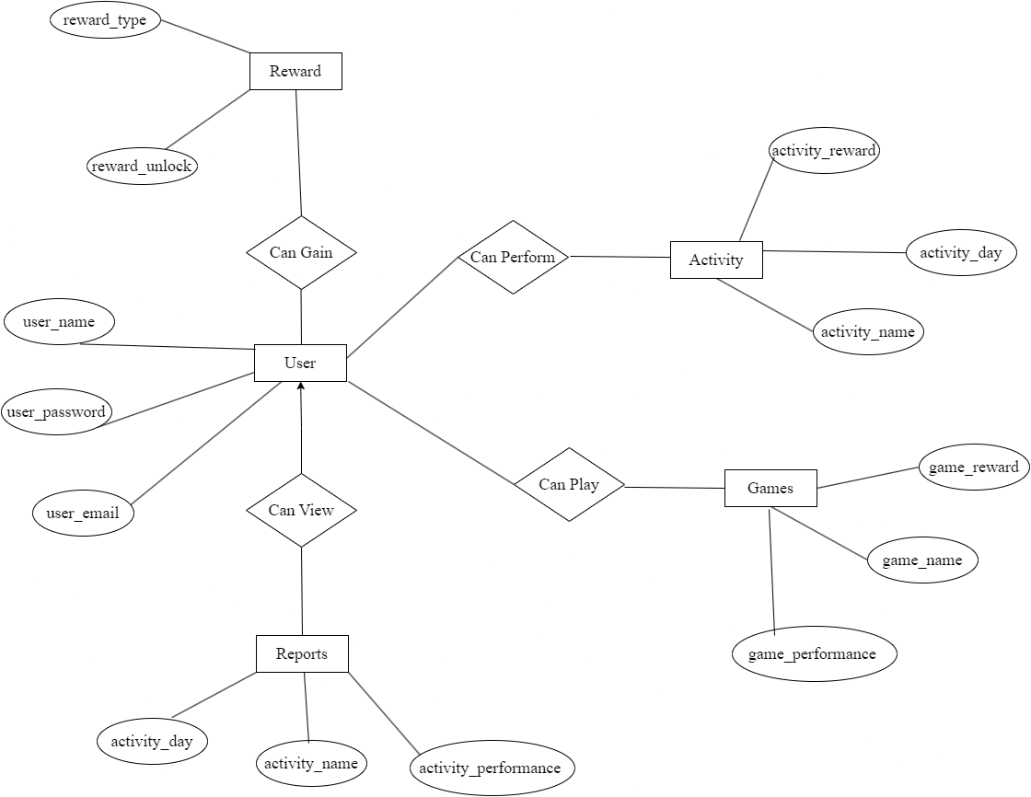

* **State Diagram:**

The name of the diagram itself clarifies the purpose of the diagram and other details. It describes different states of a component in a system. The states are specific to a component/object of a system. A State diagram describes a state machine. Now to clarify it, state machine can be defined as a machine which defines different states of an object and these states are controlled by external or internal events. As State diagram defines states it is used to model lifetime of an object. State diagram is one of the UML diagrams used to model dyna-mic nature of a system. They define different states of an object during its lifetime. And these states are changed by events.

So State diagrams are useful to model reactive systems. Reactive systems can be defined as a system that responds to external or internal events. State diagram describes the flow of control from one state to another state. States are defined as a condition in which an object exists and it changes when some event is triggered.

So the most important purpose of State diagram is to model life time of an object from creation to termination. State diagrams are also used for forward and reverse engineering of a system. But the main purpose is to model reactive system.

Following are the main purposes of using State diagrams:

o To model dynamic aspect of a system.

o To model life time of a reactive system.

o To describe different states of an object during its life time.

o Define a state machine to model states of an object.

**Symbols used in State diagram:**

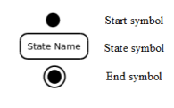

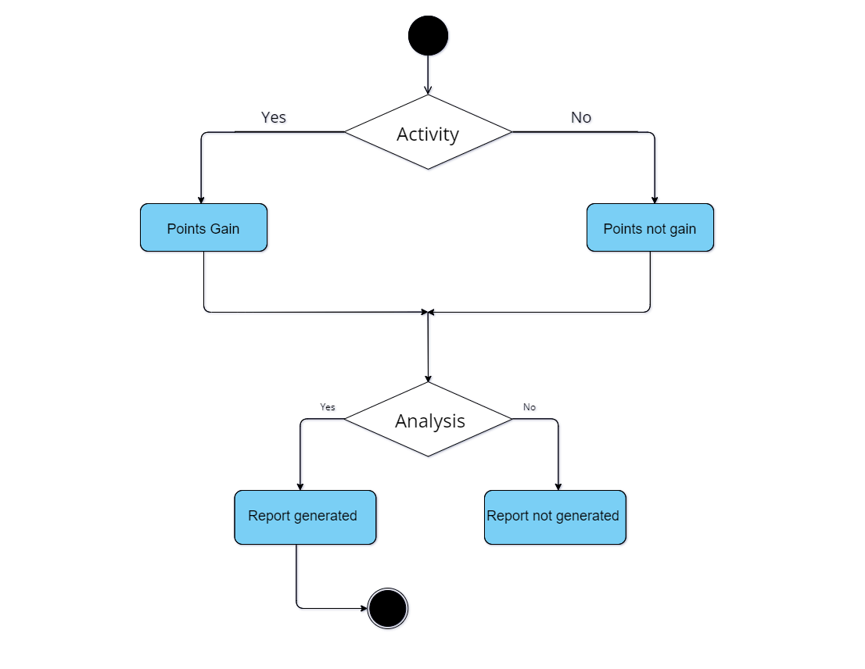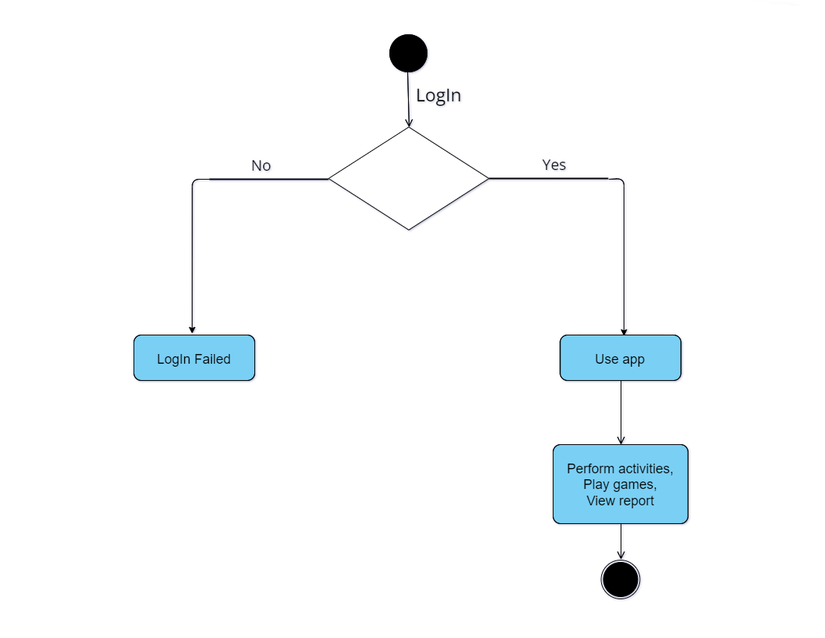

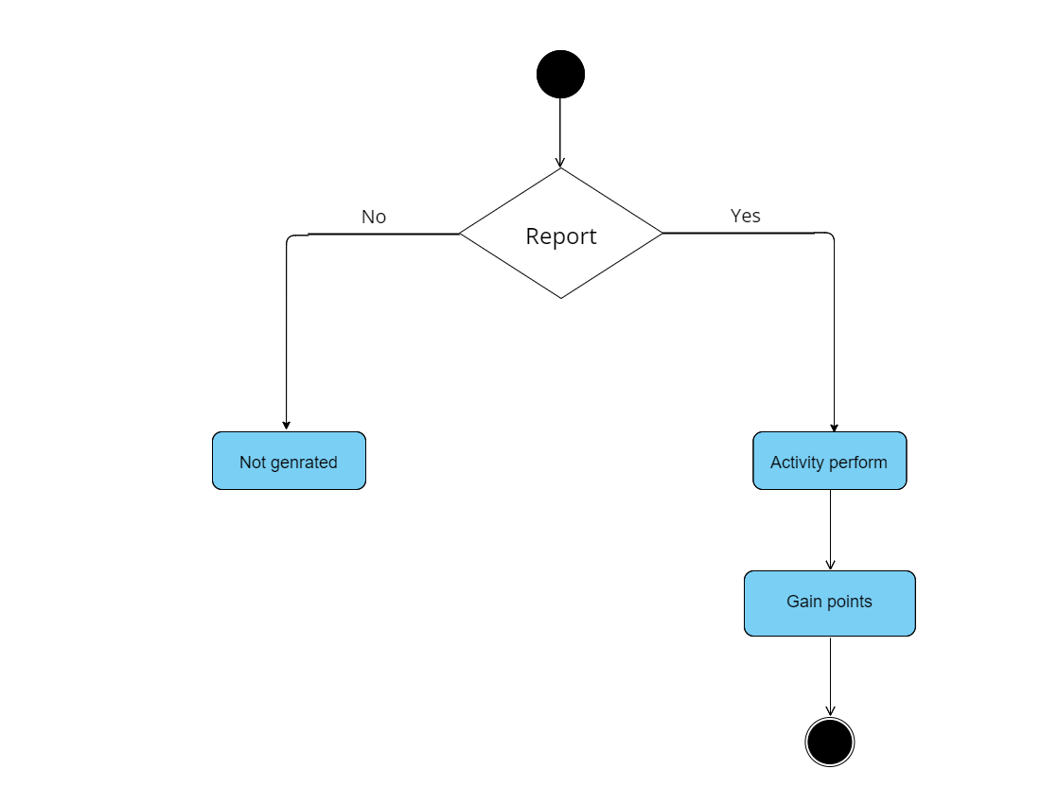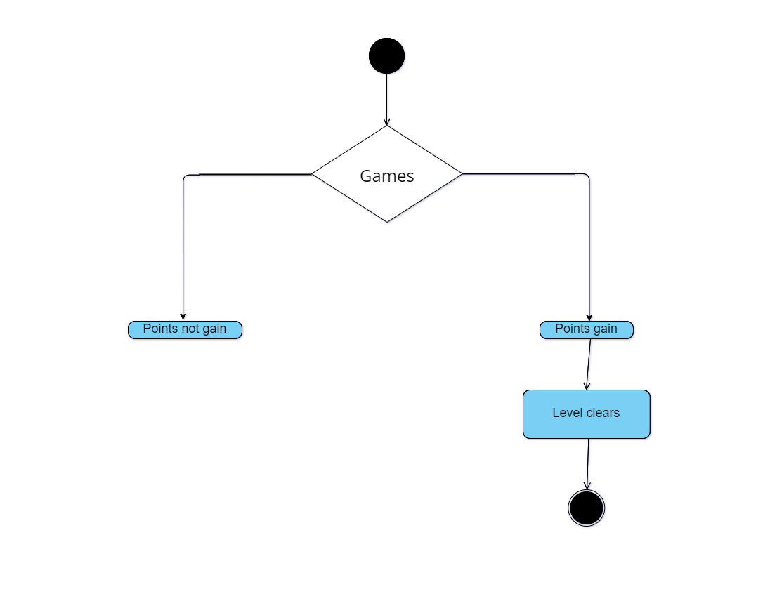

* **Data Flow Diagram :**

DFD provides the functional overview of a system. The graphical representation easily overcomes any gap between ’user and system analyst’ and ‘analyst and system designer’ in understanding a system. Starting from an overview of the system it explores detailed design of a system through a hierarchy. DFD shows the external entities from which data flows into the process and also the other flows of data within a system. It also includes the transformations of data flow by the process and the data stores to read or write a data.

Symbols used in Data Flow diagram:

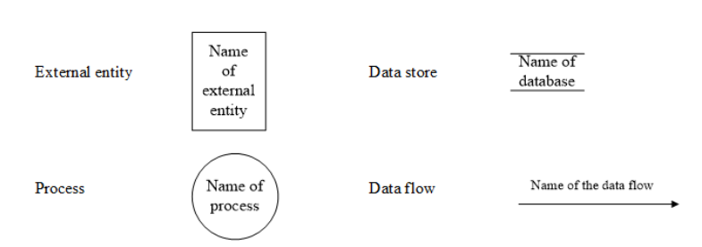

**Level-0:**

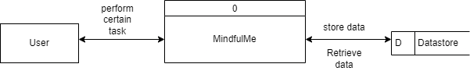

**Level-1:**

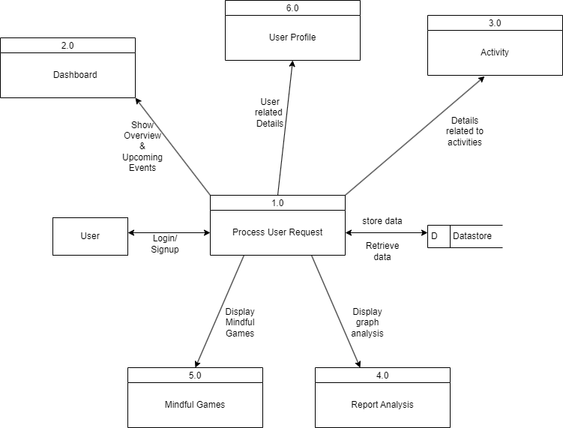

**Level-2:**

**Module-1:**

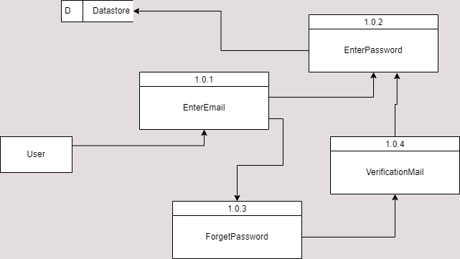

**Module-2:**

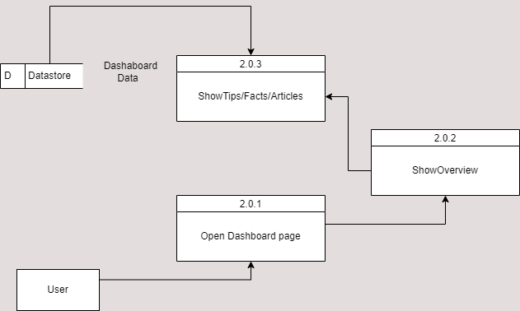

**Module-3:**

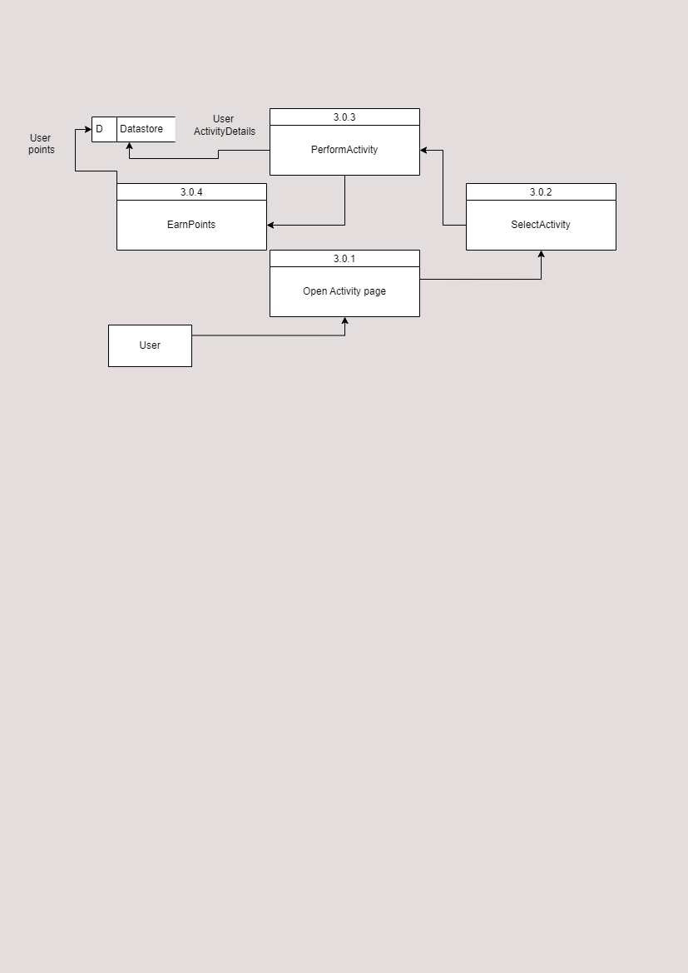

**Module-4:**

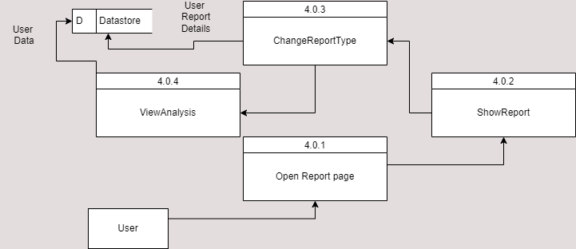

**Module-5:**

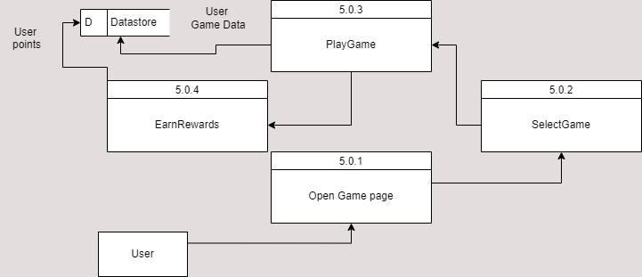

**Module-6:**

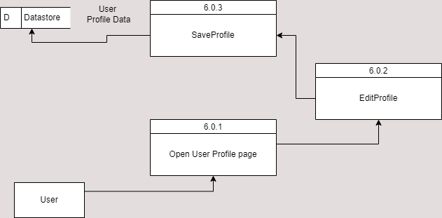

**Literature review:**

|  |  |
| --- | --- |
| **Name** | **Description** |
| Headspacew | Headspace is a widely acclaimed mobile application designed to promote mental well-being through guided meditation and mindfulness techniques. With millions of users worldwide, Headspace offers a variety of meditation sessions tailored to different needs and preferences, including stress reduction, better sleep, improved focus, and increased happiness. The app provides users with a personalized experience, allowing them to track their progress and set meditation goals |
| Neuronation | Neuronation is a comprehensive brain training app designed to enhance cognitive abilities and promote mental fitness. With a wide range of scientifically validated exercises, Neuronation offers users the opportunity to sharpen their memory, improve their concentration, and boost their overall brain function. The app features personalized training plans tailored to individual needs and goals, making it suitable for users of all ages and skill levels. |
| CogniFit | CogniFit is a leading cognitive assessment and brain training platform designed to help users optimize their cognitive health and function. Utilizing cutting-edge neuroscience research, CogniFit offers a suite of scientifically validated brain training exercises and assessments to target a wide range of cognitive skills, including memory, attention, reasoning, and processing speed. |
| I Am Sober | I Am Sober is a supportive and motivational app designed to assist individuals in their journey toward sobriety and recovery from addiction. With a focus on accountability and self-reflection, I Am Sober provides users with tools and resources to track their sobriety progress, set achievable goals, and build a strong support network. The app allows users to log their sober days, track their savings from not purchasing substances, and record their thoughts and feelings throughout their journey. |
| Happify | Happify is a science-based app designed to improve emotional well-being and cultivate happiness through evidence-based activities and techniques. Rooted in positive psychology and neuroscience research, Happify offers users a variety of engaging exercises and games that target key aspects of emotional health, such as gratitude, resilience, mindfulness, and empathy. Through personalized tracks and activities, users can explore different themes and areas of focus tailored to their individual needs and goals. |

**Comparision with our app:**

|  |  |
| --- | --- |
| **Name** | **Comparision** |
| HeadSpace | This app doesn’t include modules like Games and Reports |
| NeuroNation | This app doesn’t include Activities and only has static Instruction for exercises. |
| Cognifit | This app doesn’t include Gamification Elements while Mindfulme has it. |
| I am Sober | It mainly focuses on addiction and Mindfulme focuses on Mental WellBeing |
| Happify | It contains compliments and tips while our app focuses more on mental well being. |

**References :**

* Google : <https://www.google.com/>
* HeadSpace: <https://www.headspace.com/>
* Neuronation: <https://www.neuronation.com//>
* Cognifit: <https://www.Cognifit.com//>
* I am Sober: <https://www.IamSober.com//>
* Happify: <https://www.Happify.com/>
* Draw.io : <https://app.diagrams.net/>
* Design : <https://www.figma.com/>